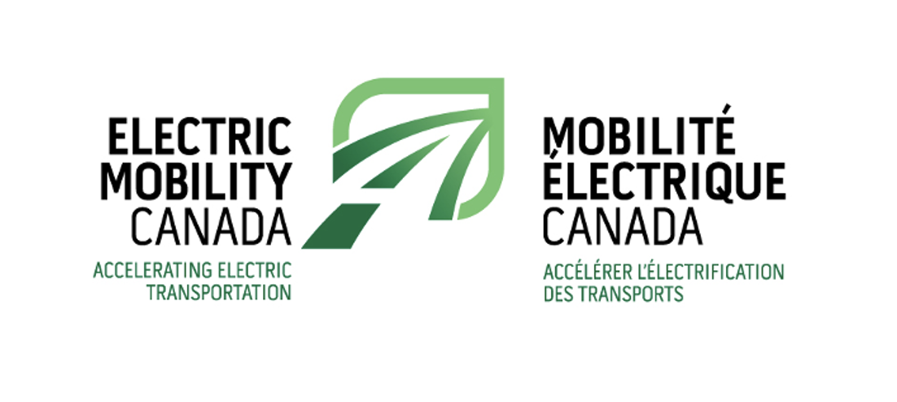

Briefing note on PBO’s report on VW and Stellantis

battery plants:

calculations incomplete and deceptive

By Electric Mobility Canada

Sept 20th 2023

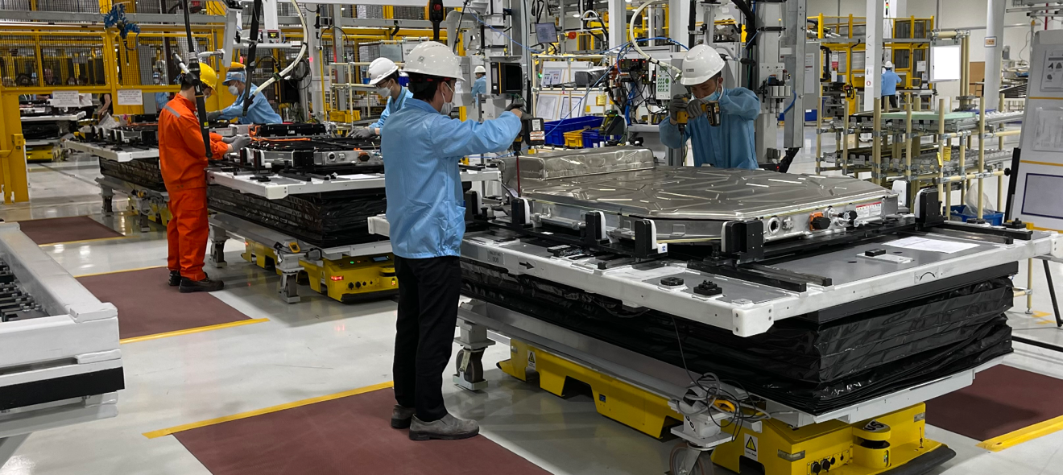

*Montreal, September 20, 2023* – Last week, the Parliamentary Budget Officer (PBO) published a Break-even Analysis of Production Subsidies for Stellantis-LGES and Volkswagen1. In this Report, the PBO estimates that it will take 20 years for government revenues generated solely from the EV battery manufacturing plants to reach the amount of production “subsidies” announced by the governments of Canada and Ontario. But the PBO break-even analysis excluded investments and production increases in other nodes of the EV supply chain.

1. **91.4% of the potential return excluded from the report**

For EMC, this exclusion is very surprising considering that the main purpose of the government financial support *is specifically aimed at developing a whole Canadian EV supply chain*. As noted in the PBO’s report “Cell manufacturing, which will occur at the Volkswagen plant, only represents a fraction of incremental revenues (8.6 per cent) across the supply chain.”

The PBO decided to exclude from its report **91,4%** of the estimated economic impact from the complete EV supply chain while saying that they based their estimation on the same Trillium Network report that does include the whole supply chain. This inherent contradiction means that the PBO’s calculations for this report are at best incomplete and even deceptive given the importance of the transition to EV manufacturing in Canada and around the world.

Based on the Trillium Network report used by Innovation, Science and Economic Development (ISED), which includes full supply-chain revenues, to estimate the break-even timeline for Volkswagen, Electric Mobility Canada (EMC) supports the break-even timeline of **less than** **5 years** for the production subsidies for the Stellantis-LGES and Volkswagen**.**

Assuming an additional $4 billion annually in government revenues at full production which is an intermediate estimation between Trillium’s scenario #1 and #3, ISED estimated that government revenues, on a cumulative basis, would be equal to the value of the production subsidy ($13.3 billion) in 3.3 years, which is consistent with the timeline announced by the Prime Minister and the Minister of Innovation, Science and Industry.

1. **The uncertainty argument is moot**

According to the PBO, the main reason why they did not consider the whole supply chain was uncertainty. We can read “Given the uncertainty surrounding the future geographic location of investments and production related to other nodes of the EV supply chain, such as EV assembly and battery material production, the PBO’s estimate represents only the government revenues generated by cell and module manufacturing, upon which the production subsidies are based. This contrasts with the federal government’s break-even analysis for Volkswagen, which included investments and assumed production increases in other nodes of the EV supply chain.”

This is already a moot argument, considering that many other investments have recently been announced by a growing number of international players who have chosen Canada as a prime location for battery component manufacturing, mining projects, battery recycling projects, EV assembly and other investments because of the Canadian government’s will to develop an EV supply chain… and more EV industry investments will be announced in the weeks and months to come.

*“After decades of seeing the Canadian manufacturing sector being slowly but surely transferred abroad and the number of manufacturing jobs shrinking, this is a monumental turnaround for the future growth of well-paid sustainable jobs for the younger generation invested in energy transition and a better environment. The fact that the PBO report is looking at these major investments in silos reveals a very outdated way of looking at the global economic, social, environmental and health impact of these investments” - Daniel Breton, President and CEO, Electric Mobility Canada*

To give a clearer picture of the level of EV manufacturing investment around the world and how certain this is where the world is headed, in October 2022, Reuters2 estimated that “The world's top automakers are planning to spend nearly **$1.2 trillion through 2030** to develop and produce millions of electric vehicles, along with the batteries and raw materials to support that production, according to a Reuters analysis of public data and projections released by those companies.”

EMC would also like to note that these significant investment numbers all around the world *do not* include investment in EV Infrastructure and grid upgrades. Just on the Canadian EV charging Infrastructure front, EMC estimates that at least **12 Billion** in revenue from sales and installation will be made between now and 2030 and that most jobs created by EV Infrastructure sales and deployment will help create Canadian jobs across Canada in manufacturing, electricity and construction.

1. **ZEV and GHG regulations get us closer to scenario 3**

When looking at the Trillium report, the PBO report indicates that “the first scenario (“Off-Target EV Adoption”) includes only EV battery- related investments announced in Canada at the time of the report, including the Stellantis-LGES facility, and ***assumes EV sales across Canada and the U.S. fall short of government announced targets***”

It’s important to note that the Trillium report was written in September 2022, before the Canadian government officially announced its ZEV sales targets3 and regulation in December 2022 and before the US government announced their own GHG emission targets and regulation in April 20234. The fact that both governments officially announced that they were going to adopt clear regulations to secure the growth in EV sales excludes scenario 1 from the most plausible investment outcomes and gets Canada closer to scenario 3.

In addition, the fact that EV sales have reached record highs in the US (10% in June 2023)5 and Canada (10,5% during Q2 2023)6 demonstrates that the EV transition is well under way.

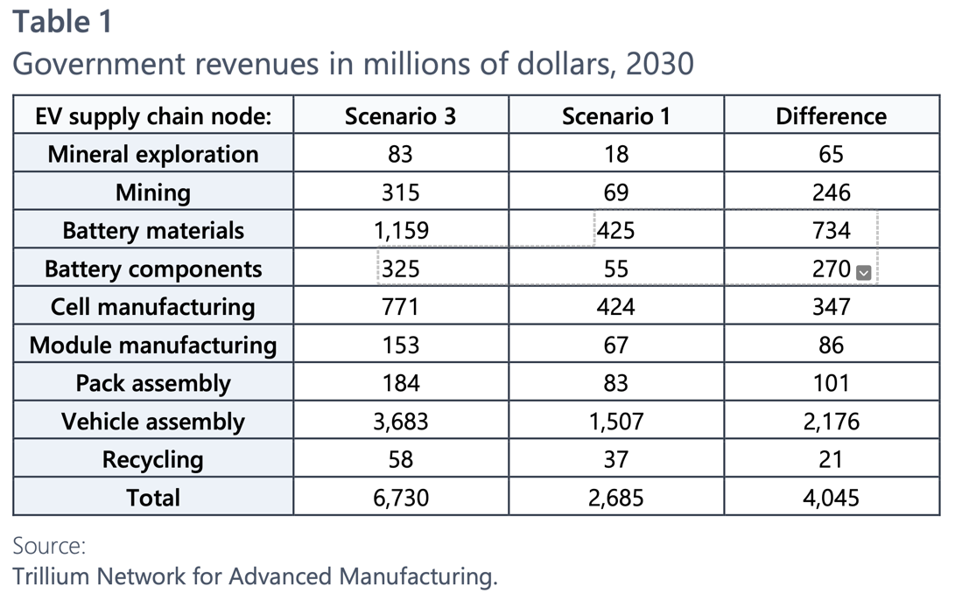

1. **A tax break is different from a subsidy**

EMC is also surprised to see that the PBO qualifies the federal government’s support for the Volkswagen production facility as a ‘’subsidy’’ since this is NOT a subsidy but a tax break. To quote Brian Lilley from the Toronto Sun7 “The Trudeau government’s offer to both VW and Stellantis is based on what is described as production tax credits. That’s not a subsidy, that’s a tax break.

That means that if you don’t produce anything, you don’t get the tax break. That’s what this is all about, a tax break, not a direct subsidy where the government cuts a company a cheque and they get to keep the money no matter what happens. There was a time when that is how governments in this country operated and it often didn’t go well for anyone involved, especially taxpayers.

You can agree or disagree with that tax break, but it is not handing money over to a company for nothing. If they don’t produce anything, they don’t get the tax break, if they produce the products, they get a tax break.”

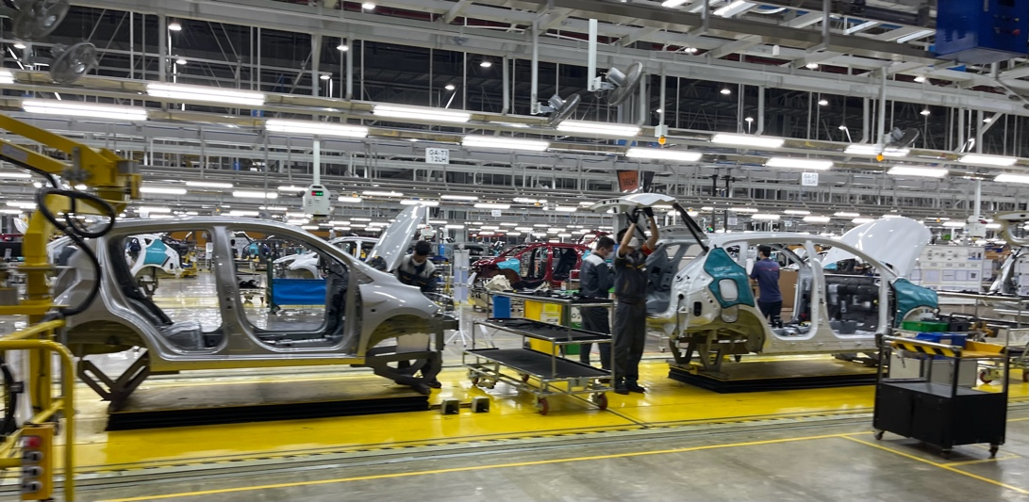

1. **Canada’s financial support of the auto industry is tied to the IRA**

EMC is also surprised to see that the PBO’s report did not mention the fact that Canada’s financial support for EV manufacturing in Canada is a direct response to the Inflation Reduction Act AND that the Canadian government has clearly stated multiple times that its level of support would be directly tied to the level of US support for EV manufacturing. If US support were to decrease or disappear for any reason between now and 2032, the Canadian financial support would decrease or disappear accordingly.

1. **The future of the Canadian auto industry is at stake**

Considering that the world is presently transitioning at a very fast pace towards EV production, everyone in the industry knows that if the federal government had decided to do nothing to help the Canadian auto sector transition to EV manufacturing, ***the risk of not having an auto sector at all by 2035 would have been overwhelming and its demise devastating.*** Considering that the Canadian auto sector plays a key role in Canada’s economy, with a $12.5 Billion contribution to GDP in 20209, we fully support the federal government in its will to accelerate the transition to EV manufacturing.

*“When I was a student, I worked at a GM assembly plant in Sainte-Thérèse, Québec. The plant was closed in 1996 to be replaced by a shopping mall. It’s pretty fair to say that average wages in an auto assembly or an EV battery plant are higher than average shopping mall wages. Beyond the number of jobs created in a region, it’s also about jobs with good enough wages to make a decent living.”* – Daniel Breton

Sources:

1: <https://distribution-a617274656661637473.pbo-dpb.ca/243471bcfade3decfc9a60ed9050b6438ccf5dca3db091709abb68793915ddeb>

2: <https://www.reuters.com/technology/exclusive-automakers-double-spending-evs-batteries-12-trillion-by-2030-2022-10->

3: <https://www.canada.ca/en/environment-climate-change/news/2022/12/proposed-regulated-sales-targets-for-zero-emission-vehicles.html>

4: <https://www.epa.gov/newsreleases/biden-harris-administration-proposes-strongest-ever-pollution-standards-cars-and>

5: <https://www.atlasevhub.com/weekly-digest/for-every-10-light-duty-vehicles-sold-in-june-one-was-an-ev/>

6: <https://www.spglobal.com/mobility/en/research-analysis/automotive-insights-q2-2023-canadian-ev-information-and-analys.html>

7: <https://torontosun.com/opinion/columnists/no-justin-trudeau-didnt-give-vw-and-stellantis-billions>

8: [https://ised-isde.canada.ca/site/canadian-automotive-industry/en#](https://ised-isde.canada.ca/site/canadian-automotive-industry/en)

9: https://ised-isde.canada.ca/site/canadian-automotive-industry/en